1. What does the dollar($) sign do?

Ans: To create an absolute reference for a Cell in the Spreadsheet, we are using the dollar sign ($) like $A$1. The dollar sign fixes the reference to a given cell so that it remains unchanged no matter where the formula moves.

1. How to Change the Reference from Relative to Absolute (or Mixed)?

Ans: By default, a cell reference is a relative reference, which means that the reference is relative to the location of the cell. If, for example, you refer to cell A2 from cell C2, you are actually referring to a cell that is two columns to the left (C minus A)—in the same row (2). When you copy a formula that contains a relative cell reference, that reference in the formula will change.

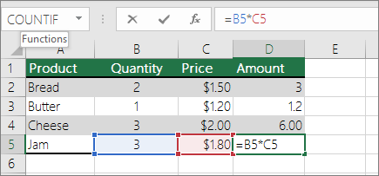

1. Explain the order of operations in excel?

Ans: When evaluating a formula, Excel follows a standard math protocol called "order of operations". In general, Excel's order of operation follows the acronym PEMDAS (Parentheses, Exponents, Multiplication, Division, Addition, Subtraction) but with some customization to handle the formula syntax in a spreadsheet.

In summary, Excel solves formulas in the following order:

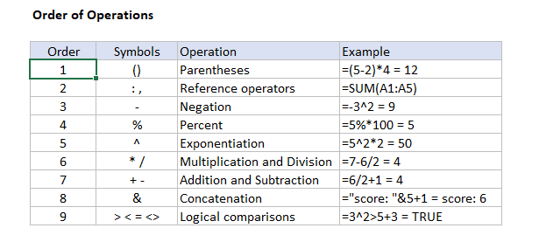

1. What, according to you, are the top 5 functions in excel and write a basic syntax for any of two?

Ans: According to me the top functions are

* VLookup Formula.
* Concatenate Formula.
* Text to Columns.
* Remove Duplicates.
* Pivot Tables.

**Concatenate Formula: “=CONCATENATE” (text1, [text2…text_n])”**

**VLookup Formula: “=VLOOKUP” (lookup_value, table_array, col_index_num, *range_lookup*)”**

1. When would you use the subtotal function?

Ans: The SUBTOTAL Function in Excel allows users to create groups and then perform various other Excel functions such as SUM, COUNT, AVERAGE, PRODUCT, MAX, etc. Thus, the SUBTOTAL function in Excel helps in analyzing the data provided.

1. What is the syntax of the vlookup function? Explain the terms in it?

Ans: **VLookup Formula: “=VLOOKUP” (lookup_value, table_array, col_index_num, *range_lookup*)”**

The each and all terms are explained in the picture below:

